HAZARDOUS AREA MONITORING

FOR INDUSTERIAL PLANT POWERED BY IoT

Team ID: PNT2022TMID01003 Project Development Phase: Sprint 3

**STEP 1 :** Make a connection between the node functions in the node red application.

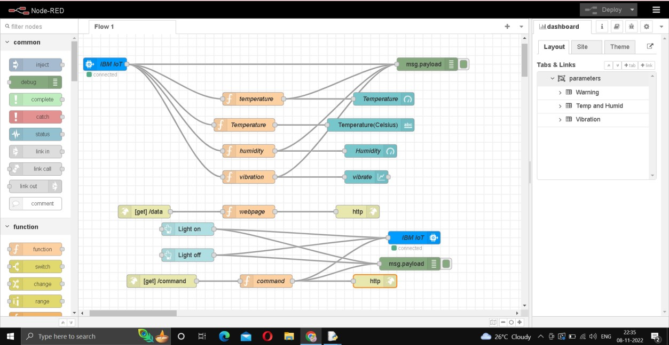

**STEP 2 :** To view the Output view the node-red dashboard.

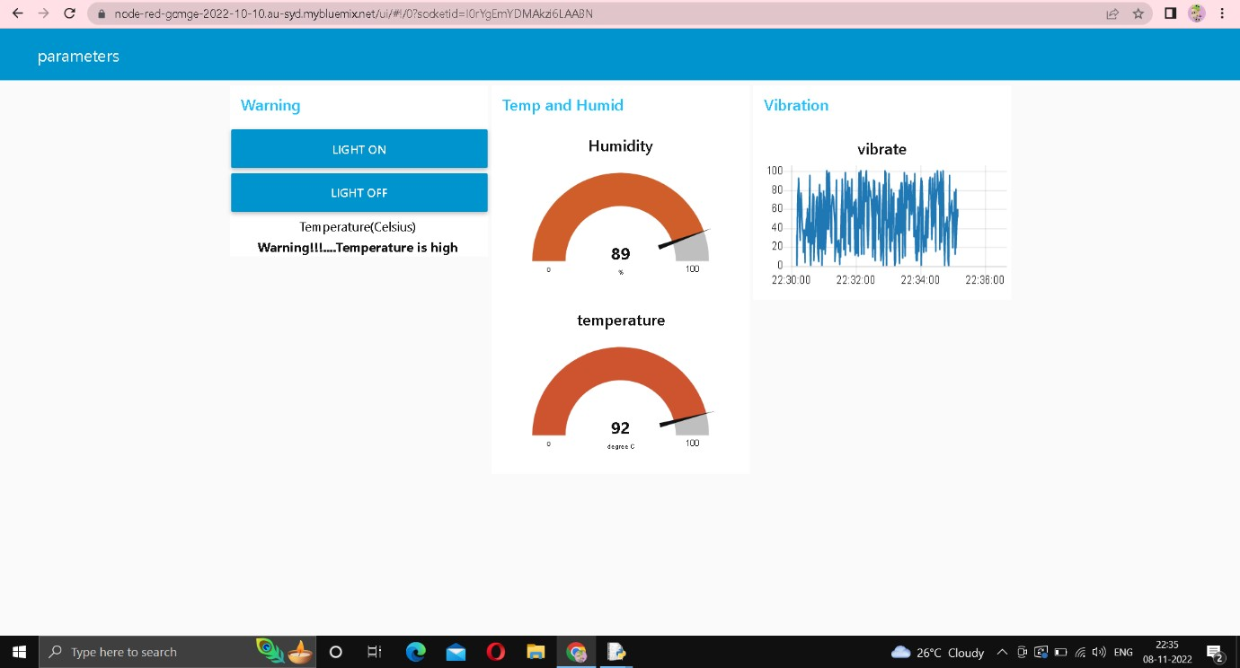

**STEP 3 :** To view the web UI copy the link in the node red upto .net/ and type data and user can view the temperature , humidity and vibration.

